Thermal energy vs HEAT
Conduction, Convention & Radiation

Heat and temperature are important concepts in all areas of science and in our everyday lives. People deal with heat and temperature all the time, yet many people hold some significant misconceptions about them. The text below tries to explain what heat is and how it moves from one place to another.
All matter is made up of particles – atoms, or groups of atoms called molecules. The particles of every object are constantly moving (even very slightly). Even in solid object where particles are held tightly in position, the particles vibrate within the position they are held in. The higher the temperature of the object the more the particles move. The hotter the object gets, the faster and more violently the particles in it are moving.
Thermal energy is the energy of those moving particles. The more the particles within the object are moving the more thermal energy it has. At higher temperatures, where the particles are moving more, the object is hotter and has more thermal energy. Sometimes the particles can move so much they move out of their position, and the object melts (but that is another topic, so we will leave it there).
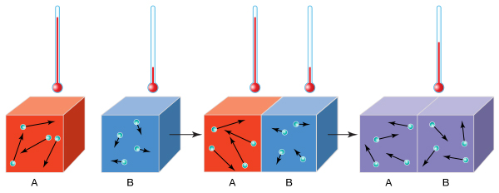
Heat is thermal energy that is in transit. Heat moves (transfers) from warmer objects to cooler objects. So technically there is no such thing as heat energy. There is only thermal energy and heat.
Thermal energy is the energy of the particles moving within an object and is related (directly proportional) to the temperature of the object.
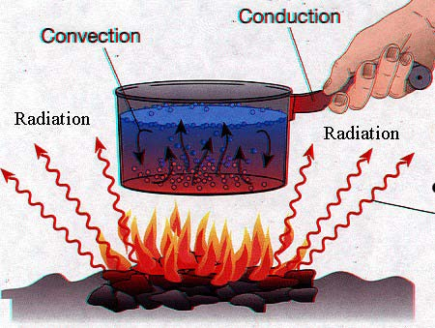
Heat is the transfer of thermal energy from one object to another because of a difference in their temperatures.
But how exactly is heat transferred from warmer matter to cooler matter?
Heat is transferred in three distinct ways which are conduction, convection or radiation. Sometimes heat is transferred by just one of these methods, but all may be occurring at any given time.

Conduction
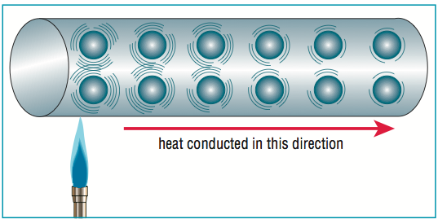
Conduction is the transfer of thermal energy from one particle to another particle it is in contact with. Conduction generally occurs within solids or when objects are in contact (your hand in water).
How conduction occurs – In a solid the particles are locked in position so they cannot move around (this is what gives solids their shape). So when heat is applied
- Where the solid is being heated, the particles vibrate faster.
- These vibrating particles hit other nearby particles and cause them to also move faster.
- This continues and increased movement (thermal energy) is transferred through the entire object.
Substances that conduct thermal energy easily are called conductors. Metals (e.g. copper, platinum, gold iron, etc.) are good conductors of thermal energy.
Substances that don't conduct heat easily are called insulators. Plastic is a good insulator. Wood falls somewhere in between.
Conduction occurs mainly in solids, or when a solid is in contact with a liquid.

Convection
Convection is the transfer of thermal energy by particles moving from one place to another. Convection occurs in liquids or gases (as their particles are free to move around). When you heat a liquid or gas, the particles move away from where they are heated to somewhere cooler, and the thermal energy is carried along with it.
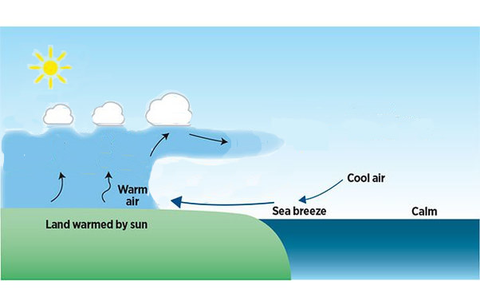
In convection, the rate of heat transfer will depend on how hot the particles are, and how freely they can move from one place to another. Thermal energy therefore travels faster in air than it does in water as air particles can move more easily. The moving particles usually set up a convection current.
Sea breeze - One very common convection current example is warm air rising in one area and cooler air falling in another area. This is a common mechanism by which heat energy is transferred within the earth’s atmosphere. When the sun heats up the ground, the air above it is heated. This causes the air to expand and become less dense - so it rises. The rising warm air loses its heat as it rises and is forced to move sideways and eventually move downwards in areas where the surface is being heated less by the sun. This is how sea breezes on the sunshine coast are caused.
On a global scale, these types of air movement patterns within our atmosphere not only transfer heat from one part of the earth to another, they also cause most of our weather!
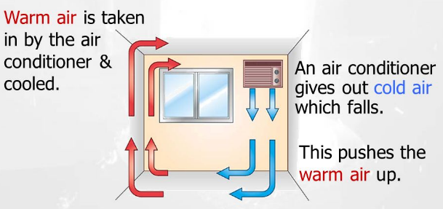
Air conditioners cause convection loops by cooling air and blowing it into a room. The cold air is more dense than the worm air in the room so it sinks to the floor. This cause warmer air to rise on the other side of the room and a convection current is set up circulating the cool air around the room.
Convection currents play an important role in spreading heat through our atmosphere and within our oceans. Another common convection current are those seen in heating liquids on a stove.

Radiation
Radiation is the transfer of thermal energy by electromagnetic radiation. Radiation does not rely upon any contact between the heat source and the object being heated. For example, we feel heat from a fire even though we are not touching the fire (conduction), nor is air moving from the fire to us (convection). Radiation transfer thermal energy through space and transparent things such as air and glass. Radiation cannot travel through opaque objects like surfaces and walls. When radiant heat hits a solid wall, the energy is absorbed and then transferred by conduction through the wall.
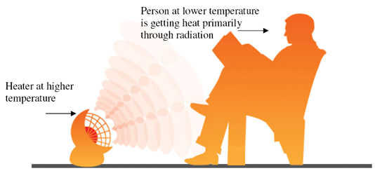
thermal energy can be transferred by all types of electromagnetic radiation, but mainly by infrared waves (a type of electromagnetic wave, like visible light). Any objects with thermal energy will naturally emit some infrared waves – even us! Hotter objects, which have a lot more thermal energy than cooler ones will emit more infrared waves. The warmth of the sun, a campfire, or an open oven door are all common examples of hot objects releasing infra-red radiation which transfers thermal energy from the hot place to a colder place (you).

Heat and Thermal energy – Wrtten answer questions - The answers in the notes.

- What is the difference between thermal energy and heat?

- Define conduction

- Nate was stirring hot soup on the stove. Why should he use a wooden spoon instead of a metal spoon? (Key words – conduction, insulator, conductor)

- Define convection

- Amber bought a coat with goose down (tiny feathers) insulation to keep her warm in the winter in Utah. Explain why a coat filled with goose down is a good choice to keep her warm. You may need some research on this one – do a good answer, don’t be lazy.

- Define Radiation

Heat and Thermal energy - True or False Questions

- Decide whether the following statements are True or False. Circle the correct answer.

- Everything has some thermal energy. | TRUE or FALSE
- Heat energy is another way of saying thermal energy. | TRUE or FALSE
- Heat travels from warmer to colder places. | TRUE or FALSE
- Conduction of heat only occurs in solids or when objects are in contact each other. | TRUE or FALSE
- When an object is heated, the particles present move slower. | TRUE or FALSE
- Materials containing air are usually good insulators. | TRUE or FALSE
- Convection occurs in fluids due to movement of the particles in these fluids. | TRUE or FALSE
- The Sun is a major source of infrared radiation. | TRUE or FALSE
- Shiny surfaces are good absorbers of heat radiation. | TRUE or FALSE
- Infrared rays travel at the speed of light. | TRUE or FALSE
- Only objects that feel warm to the touch have heat energy. | TRUE or FALSE

Heat and Thermal energy – Multiple choice questions (only one answer is correct)

Which of the following is an example of heat conduction?
a) An air vent from a furnace sending hot air into the house.
b) A metal cup heating up when hot water is poured into it.
c) The sun melting the ice formed on a frosty lawn.
d) Cool air sinking to the ground on a cold night.

By what process does heat energy travel from the sun to the earth?

a) Heat is radiated through space.
b) Heat is conducted through air particles.
c) Convection of heat through air currents.
d) Heat travels through the wind.

In a room in the wintertime, where would you find the warmest air?
a) near the ceiling b) near the floor
c) in the corners d) by a window

Which of the following is not a method of heat transfer?
a) Conduction b) Convection
c) Condensation d) Radiation

Which of the following is the best conductor of heat?
a) air b) plastic
c) water d) aluminum

Which of the following is the worst conductor of heat in the group?
a) air b) plastic
c) a vacuum d) aluminum

Which of the following is the best conductor of heat in the group?
a) air b) plastic
c) a vacuum d) aluminum

The fact that liquids and gases expand and lower their density when heated causes

a) convection currents in fluids.
b) convection currents in solids.
c) heat transfer by conduction.
d) radiation currents in fluids.

In which of the following would convection currents occur?
a) air b) a vacuum
c) plastic d) aluminum

The methods of heat transfer that causes a pot of water on a stove to boil are
a) conduction and radiation. b) conduction and convection.
c) radiation and convection. d) conduction, convection and radiation.

This type of heat transfer can occur in a vacuum:
a) Conduction. b) Convection.
c) Radiation. d) Blackbody.

Heat transfer by radiation
a) is not possible from human beings to their environment.
b) only occurs in the dark.
c) does not require any material between the radiating object and the object receiving the radiation.
d) none of the above.

Which one of the following statements concerning the transfer of heat is not correct?
a) Conduction and convection may take place in solids.
b) Convection may take place in liquids and gases.
c) Radiation and conduction may take place in solids.
d) Conduction may take place in solids and liquids.

Which of the following methods of heat transfer involves the actual physical movement of hot particles to regions of lower temperature?
a) condensation b) conduction
c) convection d) radiation

If one's hands are being warmed by holding them out towards a fire, the main form of heat transfer occurring is which of these processes?
a) conduction b) radiation
c) convection d) Vaporization

The transfer of energy by the movement of fluids or gases with different temperatures is called:
a) convection. b) conduction.
c) radiation. d) contact.

Heat and Thermal energy – identifying the method of heat
- Select the correct mode of heat (transfer) for each of the following examples (Conduction, convection, or radiation)
The heat you feel from a fireplace
Frying a pancake in a frypan
Air travels this way (the wind)
Transfer through solids
Transfer through space
Sun rays reaching earth
Occurs with fluids and not in solids
You burn your tongue drinking hot chocolate.
A spoon in the hot chocolate becomes warm
On a sunny day, the sand at the beach can get very hot

Heat and Thermal energy – Complex questions (have to think about these… try to identify the method of heat transfer and then explain how it is occurring using the correct scientific words and the words on the question)
- A saucepan might have a copper bottom but a plastic handle

- Why air conditioners always installed near the ceiling of the room

- If you put your hand above a burning match, your hand feels hot. However, your hand does not feel particularly hot when it is underneath the burning match

